ASSIGNMENT - 7

PROBLEM STATEMENT - Hosting a Website on EC2.

To host the website

STEP 1- Create 3 Static Webpages using HTML.

STEP 2- Click on the “EC2” button.

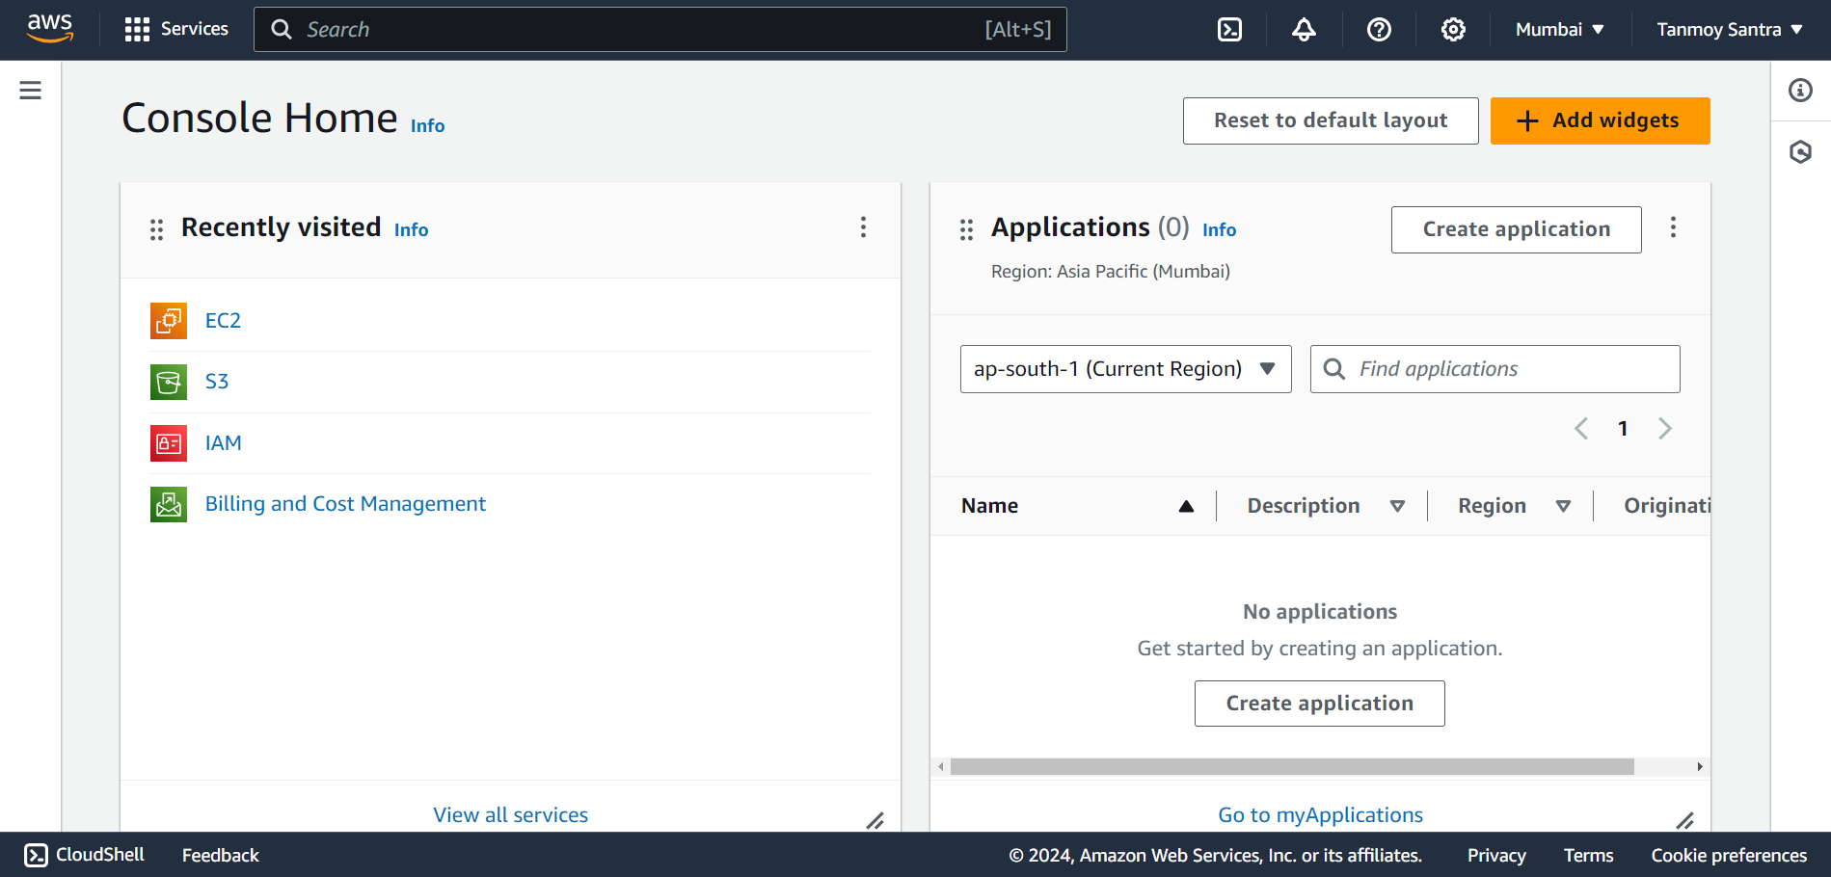

STEP 3- Click on the “Launch Instance” button.

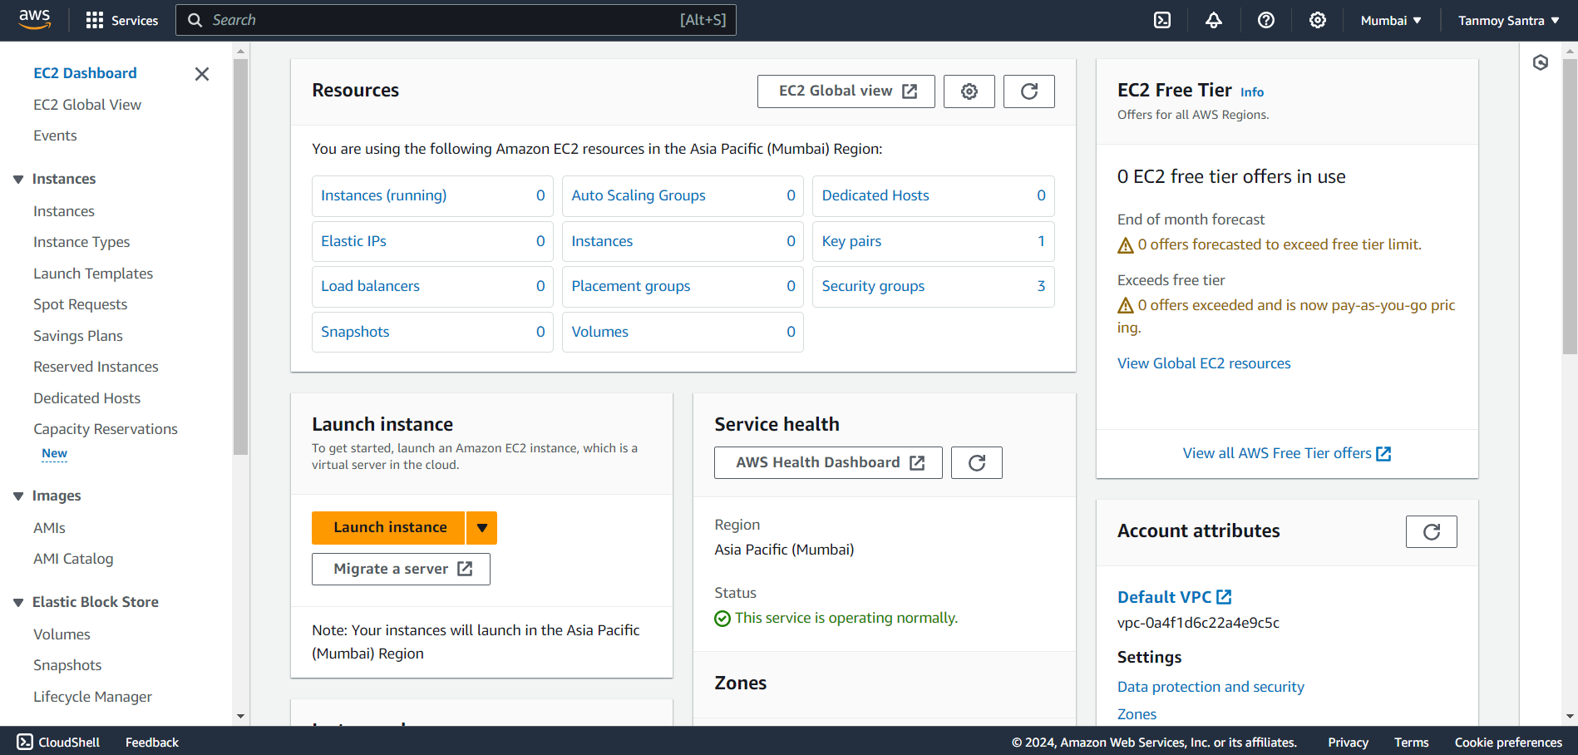

STEP 4- Give a name to the instance & select “Ubuntu” .

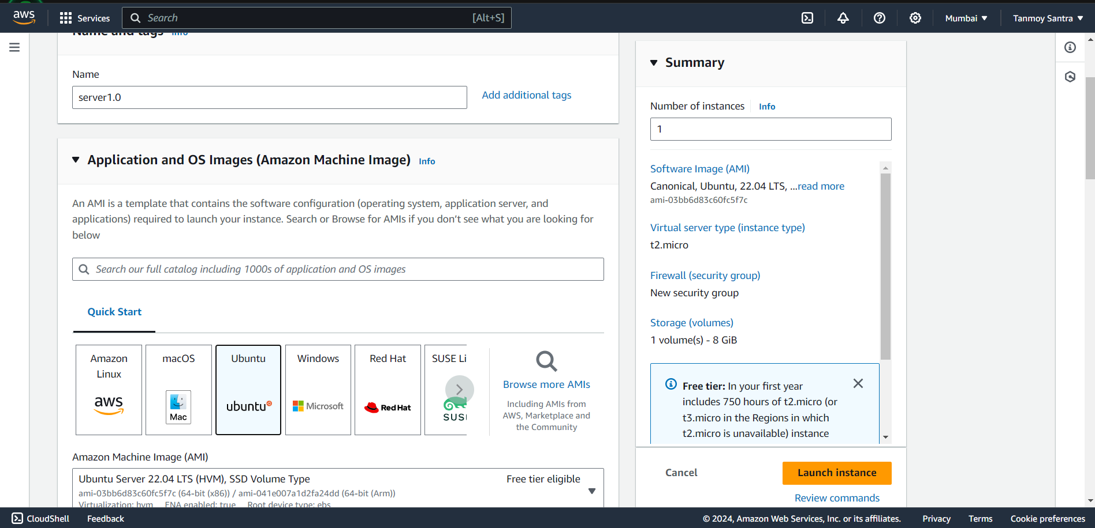

STEP 5- Create a new one by clicking on “Create New Key Pair” button.

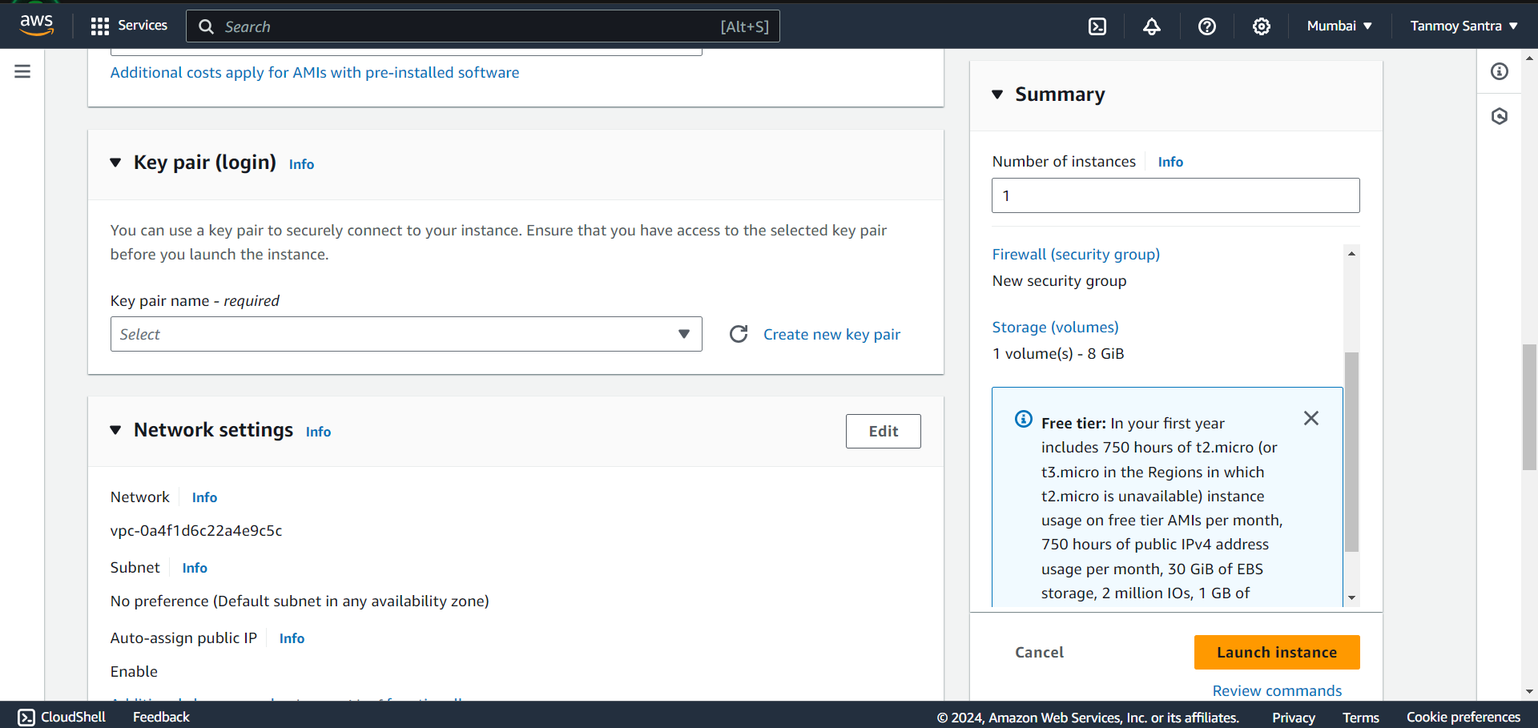

STEP 6- Give a name to the key pair. Then click “Create Key Pair”.

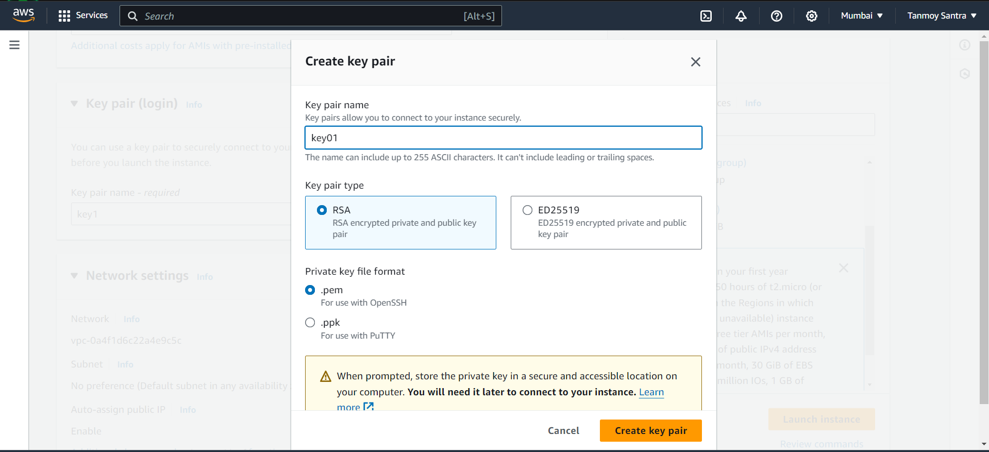

STEP 7- Select all the Security options. Then click on “Launch Instance”.

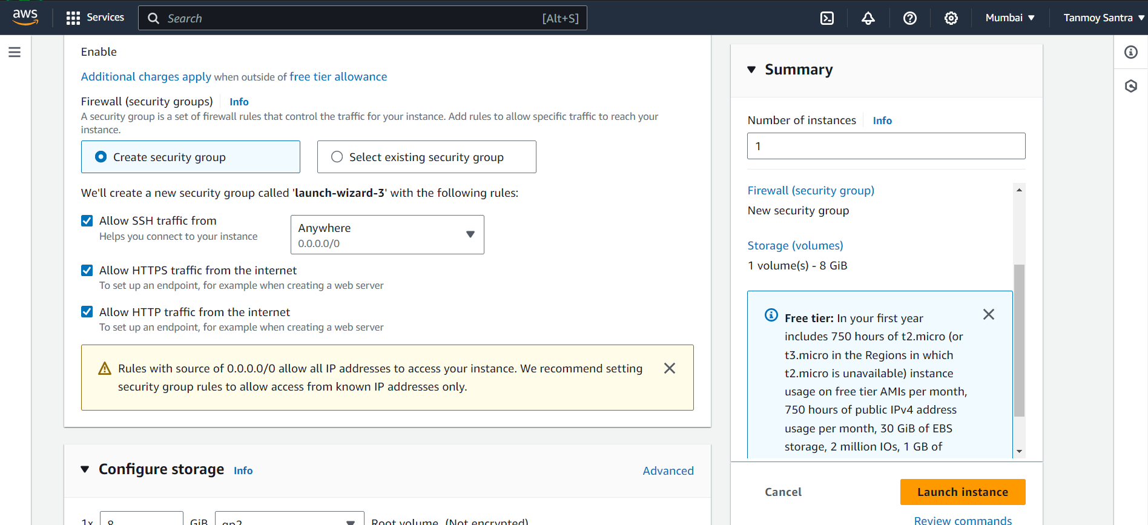

STEP 8- The new instance is thus created successfully. To Enter the Instance click on its ID.

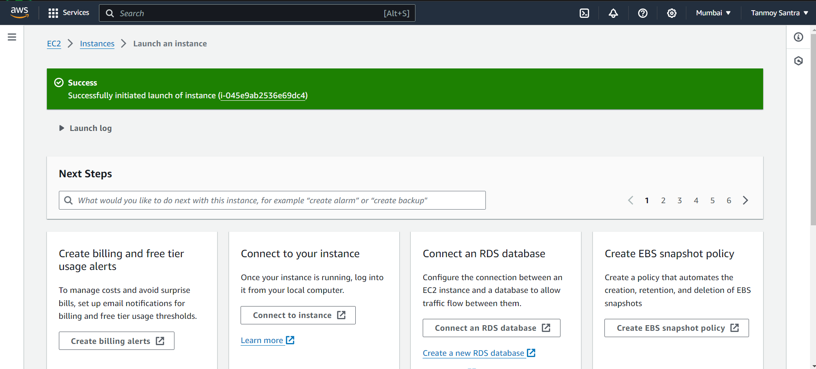

STEP 9- Copy the “Public IPv4 Address” of the instance.

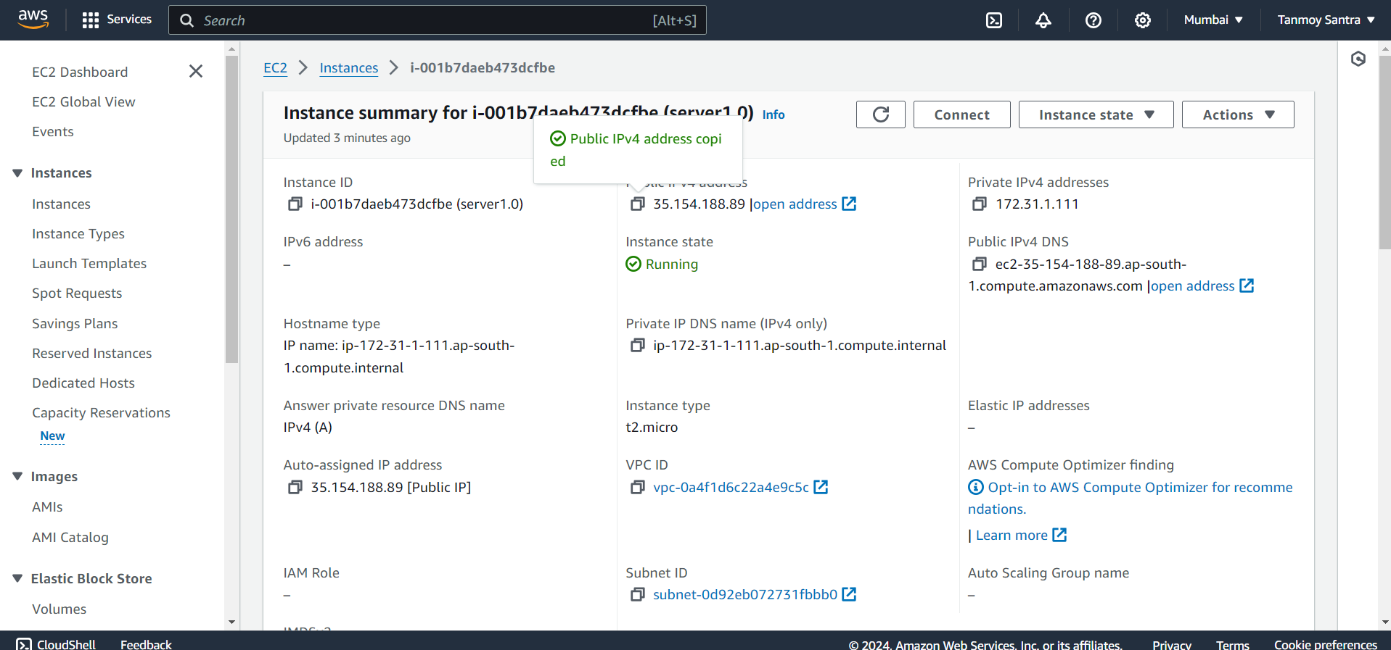

STEP 10- open SSH client Paste IP address under Host. Then go to the “Client Key Manager” option.

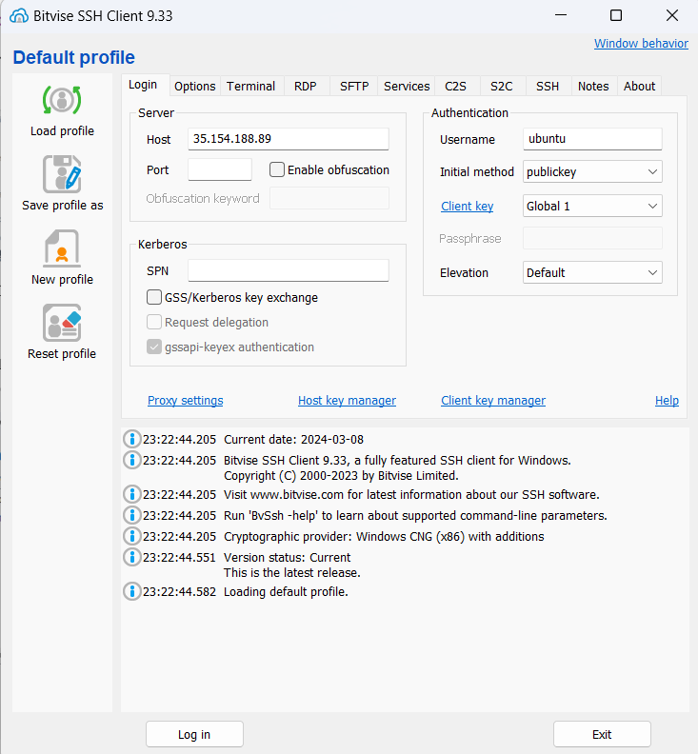

STEP 11- Click on the “Import” button & select the key & click “Import”. The new key is successfully added. Click “Import”.

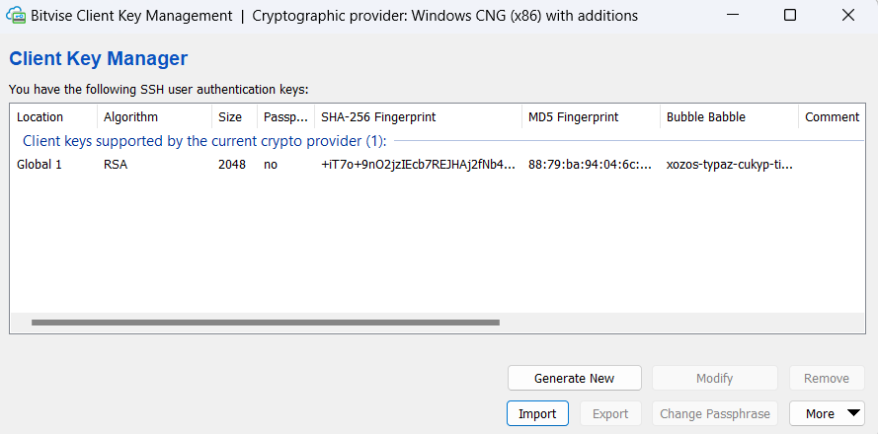

STEP 12- Give the username as “ubuntu, select “Public Key” & ” select “Global1”. Then click the “Log in”button.

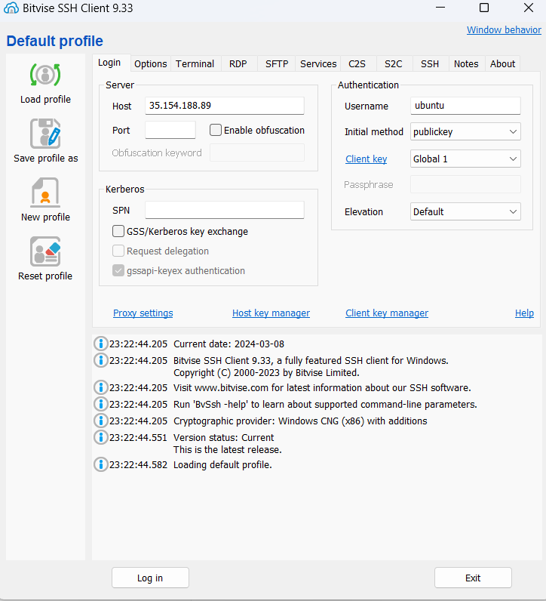

STEP 13- Click on the “Accept & Save” button.

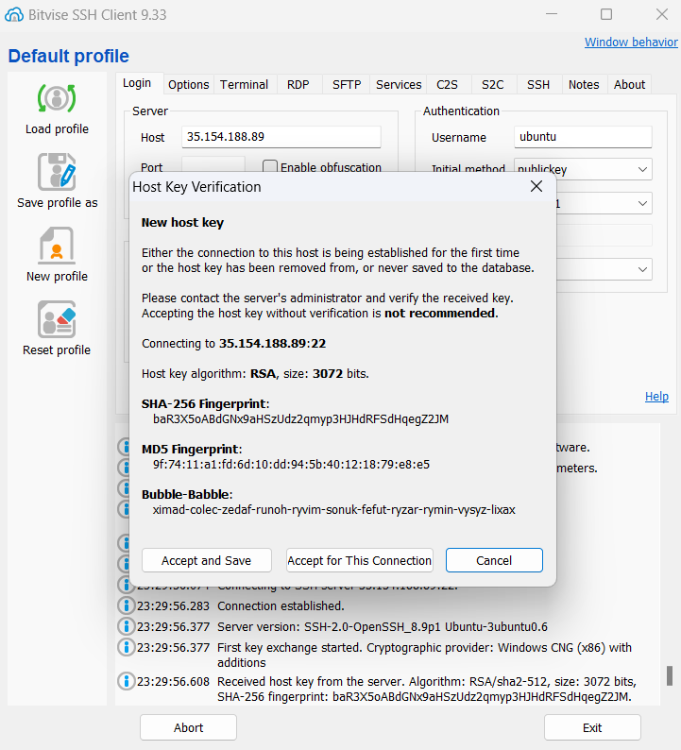

STEP 14- Now the client is connected.

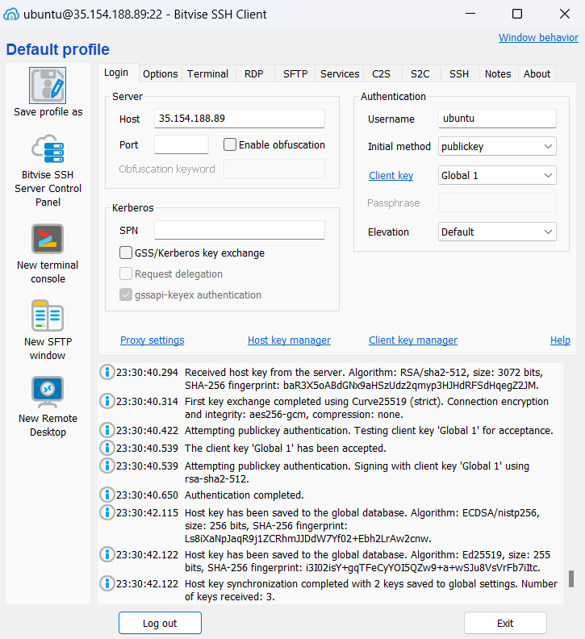 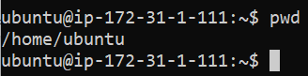

STEP 15- Click on the “New SFTP Window” button.

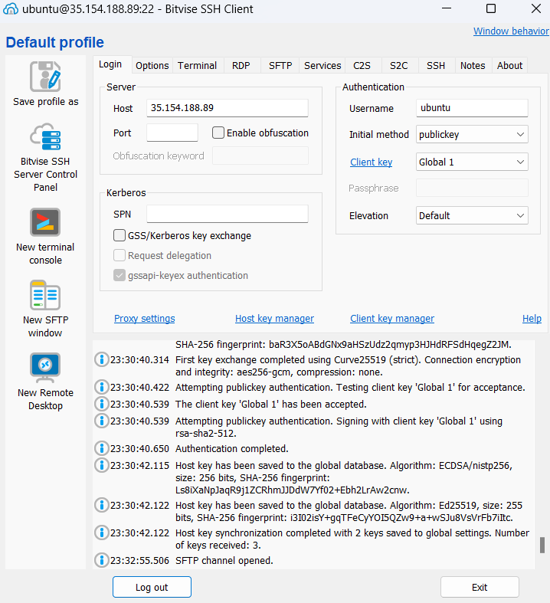

STEP 16- Under Local Files open the folder where the HTML files are present.

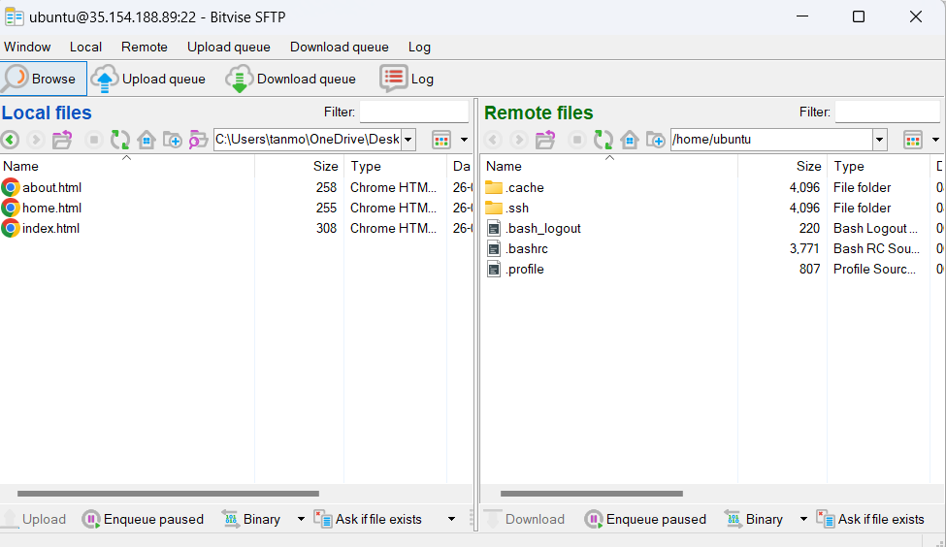

STEP 17- Go to the terminal and type the following commands.

“ sudo apt-get update “ , ” sudo apt-get upgrade “ , “ sudo apt-get install nginx ”

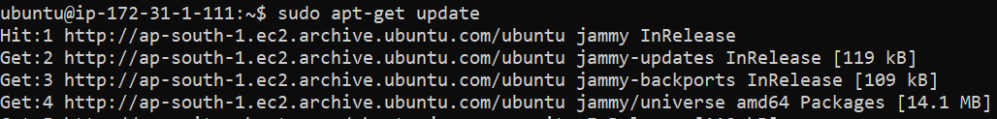

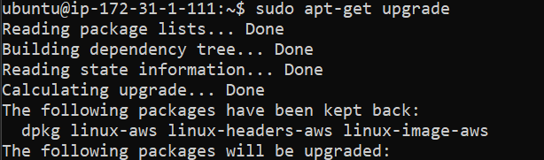

Press ‘tab’ then ‘ok’ hit enter.

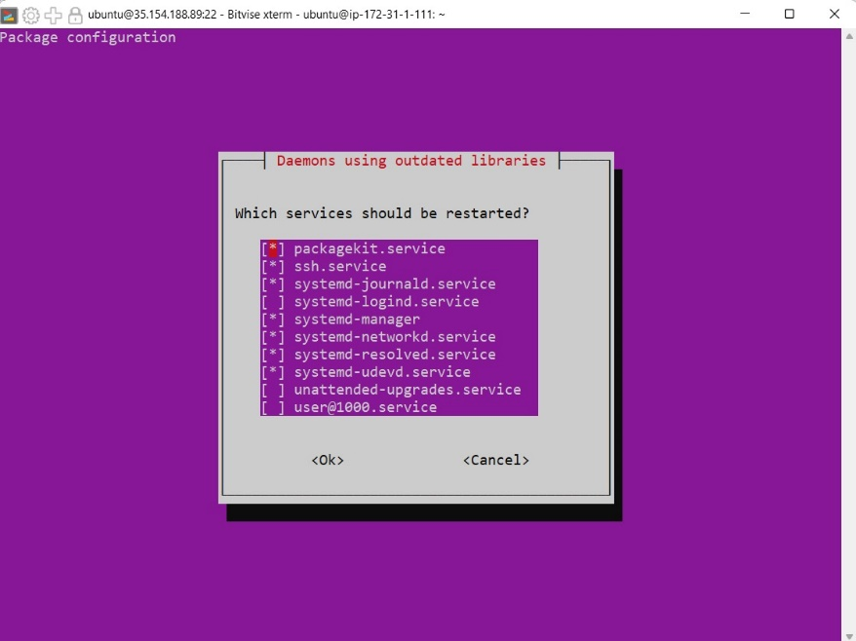

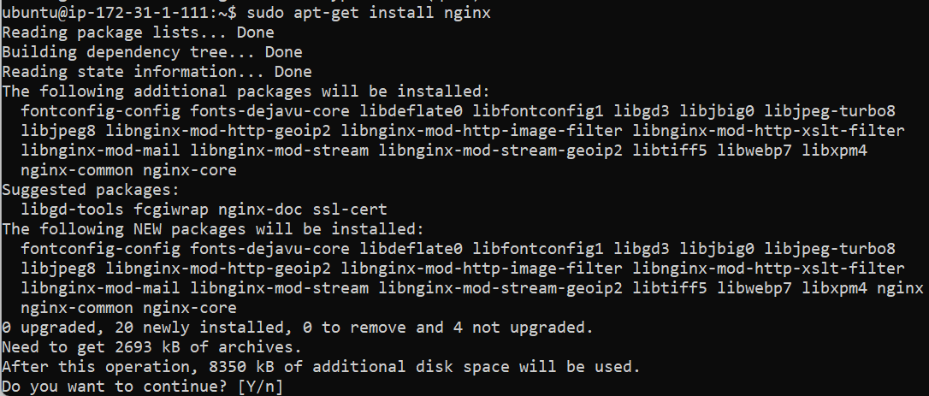

STEP 18- Type the command

Cd /

Cd var

Cd www

“sudo chmod 777 html” and press “Enter”.

Cd html

Ls

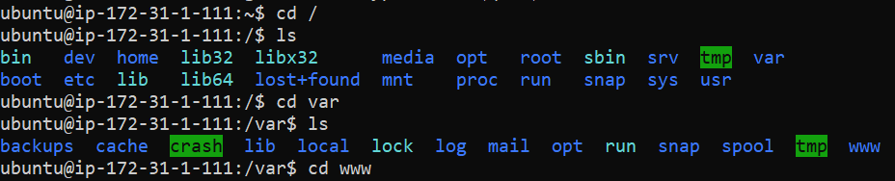

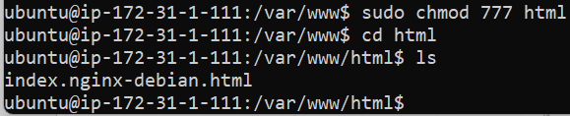

STEP 19- Now going back to the “SFTP Window” under the “Remote Files” open the HTML directory and

drag & drop the HTML files.

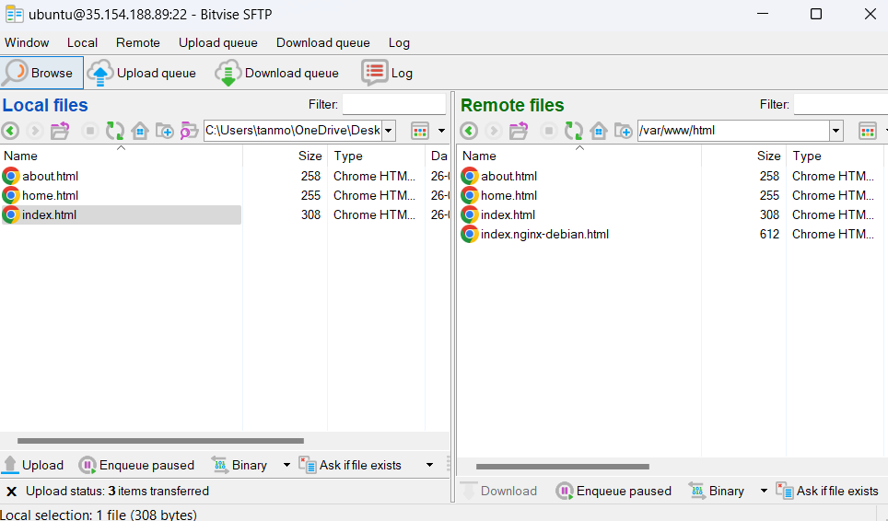

STEP 20- Now go back to the “AWS Window” and click on the “Open Address” button beside the IP address.

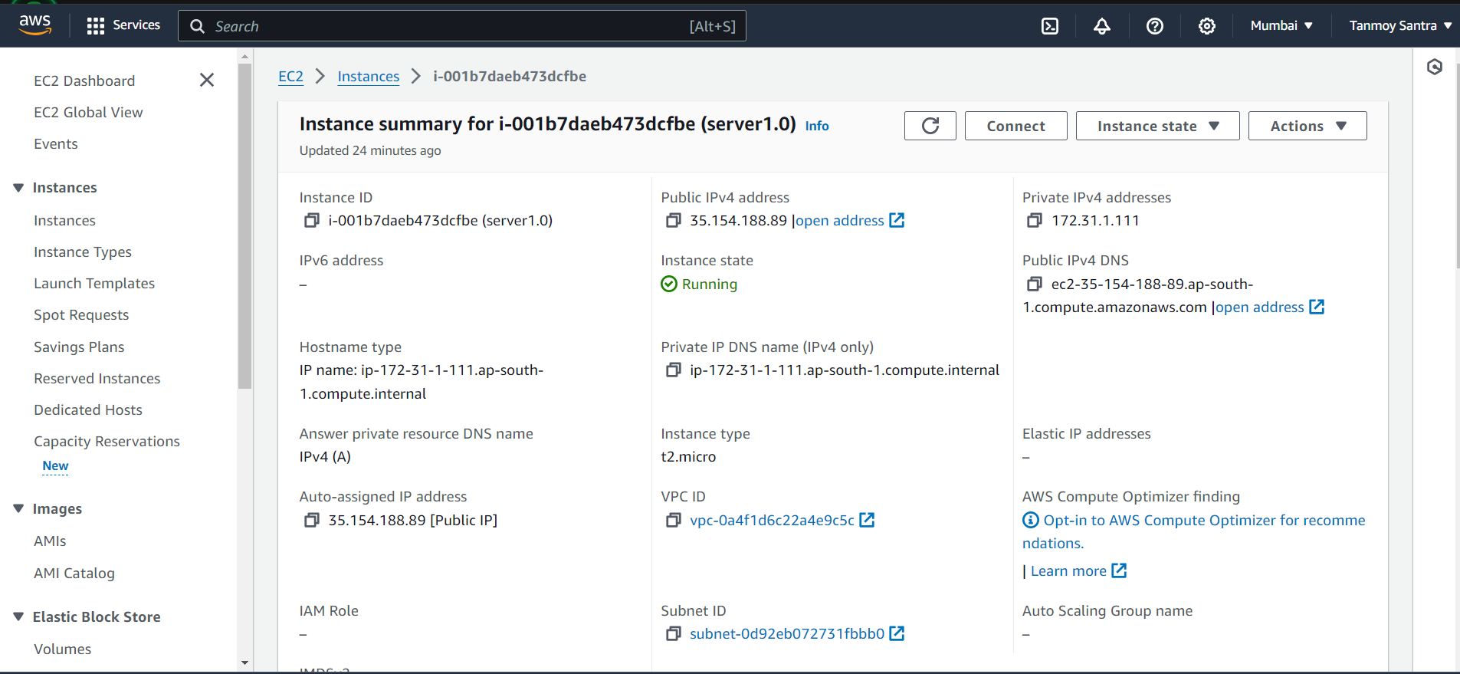

STEP 21- A new window will open with the webpage.

